

**DAY 8 – INFORMATICS TRAINING**

**Exercise 1**

Create a program called ‘4 in Line’ or ‘Connect 4’ with the following layout:

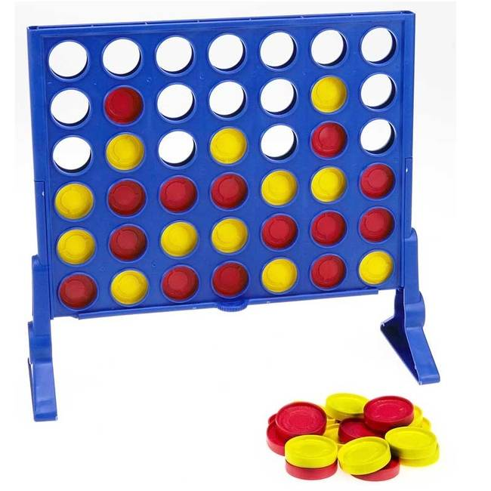

Connect Four is a two-player connection board game, in which the players choose a colour and then take turns dropping coloured discs into a **seven**-column, **six**-row vertically grid.

The objective of the game is to be the first to form a horizontal, vertical, or diagonal line of **four** of one's own (red or yellow) discs.

Email your project results in a .Rar or .Zip format to eduplus.luiscunha@gmail.com